

*java iot developer Lab*

Lab -6

**SUBMITTED BY: SUBMITTED TO:**

**AYUSH KUMAR JHA Dr. SURBHI SARASWAT**

**SAP ID - 500086400**

**Enrollment no - R200220083**

**B.C.A -I.O.T.**

Questions :-

Q1. On an LCD display a scrolling text (that scrolls in both direction). Add text in both the lines. Example was shown in the lab.

#include <LiquidCrystal.h>

//Initialise the LCD with the arduino.

//LiquidCrystal(rs, enable, d4, d5, d6, d7)

LiquidCrystal lcd(12, 11, 5, 4, 3, 2);

void setup() {

// set up the LCD's number of columns and rows:

lcd.begin(16, 2);

// Print a message to the LCD.

lcd.setCursor(18,0);

lcd.print("Welcome");

lcd.setCursor(16,1);

lcd.print("14 Mar-22!");

}

void loop() {

lcd.display();

for (int positionCounter = 0; positionCounter < 31; positionCounter++) {

// scroll one position left:

lcd.scrollDisplayLeft();

// wait a bit:

delay(100);

}

for (int positionCounter = 0; positionCounter < 32; positionCounter++) {

// scroll one position left:

lcd.scrollDisplayRight();

// wait a bit:

delay(100);

}

//dISPLAY DETAILS

delay(100);

}

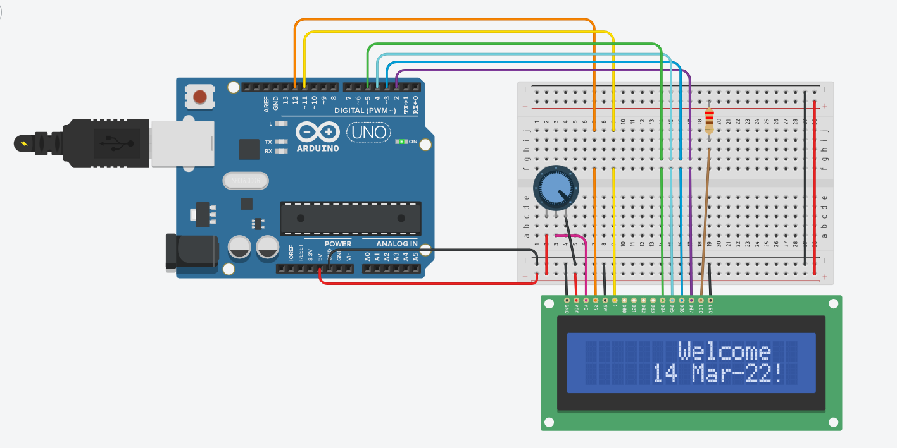

Q2. Read the sensor value from a temperature sensor and display it on a serial monitor and an LCD.

// Import/include the Liquid Crystal library

#include <LiquidCrystal.h>

//Initialise the LCD with the arduino.

//LiquidCrystal(rs, enable, d4, d5, d6, d7)

LiquidCrystal lcd(12, 11, 5, 4, 3, 2);

const int temperature = A0; //A0 is the analog pin

const int D = 8;

void setup() {

// set up the LCD's number of columns and rows:

lcd.begin(16, 2);

lcd.setCursor(1,0);

lcd.print("Tempreture:");

// Print a message to the LCD.

Serial.begin(9600);

pinMode(D, OUTPUT);

}

void loop() {

// Turn off the display:

delay(500);

// set the cursor to column 0, line 1

// (note: line 1 is the second row, since counting begins with 0):

digitalWrite(D,LOW);

int Temp = analogRead(temperature);

float volts = (Temp / 965.0) * 5;

float celcius = (volts - 0.5) * 100;

float fahrenheit = (celcius * 9 / 5 + 32);

Serial.println(fahrenheit);

lcd.setCursor(5,1);

lcd.print(fahrenheit);

delay(2000);

// Turn on the display:

lcd.display();

delay(500);

}

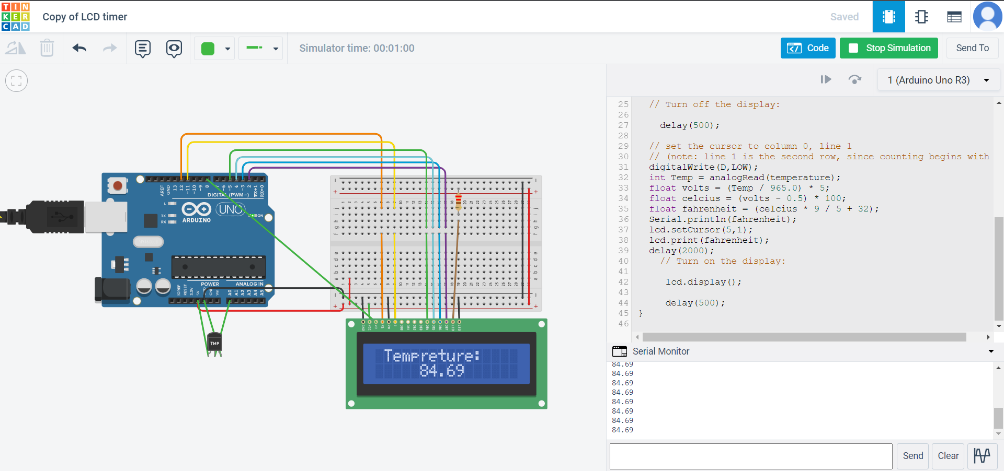

Q3. Using serial communication, send a message from serial terminal to the LCD.

// Import/include the Liquid Crystal library

#include <LiquidCrystal.h>

//Initialise the LCD with the arduino.

//LiquidCrystal(rs, enable, d4, d5, d6, d7)

LiquidCrystal lcd(12, 11, 5, 4, 3, 2);

const int D = 8;

String input;

void setup() {

// set up the LCD's number of columns and rows:

lcd.begin(16, 2);

lcd.setCursor(1,0);

lcd.print("INPUT:");

// Print a message to the LCD.

Serial.begin(9600);

pinMode(D, OUTPUT);

}

void loop() {

delay(500);

digitalWrite(D,LOW);

if(Serial.available()){

input = Serial.readStringUntil('\n');

Serial.print("You typed: " );

Serial.println(input);

lcd.setCursor(7,0);

lcd.print(input);

delay(2000);

}

lcd.display();

delay(500);

}

